ChessNuggets UserManual
Version 1.0 Android Application
Chess
Authors: Tobi Winkels-Herding and Kinson Michel
6/18/2014

About This Guide

The ChessNuggets User Manual for the ChessNuggets Android application is for beekeepers that have Android version 4.0 or higher running on their phones or tablets. The purpose of this guide is to illustrate the basic functionalities and features of the application and instruct the users on how to install and use this chess statistical application.

Contents
1. Overview 2
2. Installing the App 2
3. User Tasks 2
4. Maintenance 5

1. Overview
The following features available on this version of the application:
- Login
- Synchronize
- Likely opponent and chance of winning
- Players ranking by points and rating
- Player Profile

2. Installing the App
Connect Android device to PC via USB cable and turn on USB storage.
Copy .apk file to the device's storage.
Turn off USB storage and disconnect it from PC.
Check the option Settings → Applications → Unknown sources.
Open FileManager app and click on the copied .apk file.
It will ask you whether to install this app or not. Click Yes or OK.

3. User Tasks
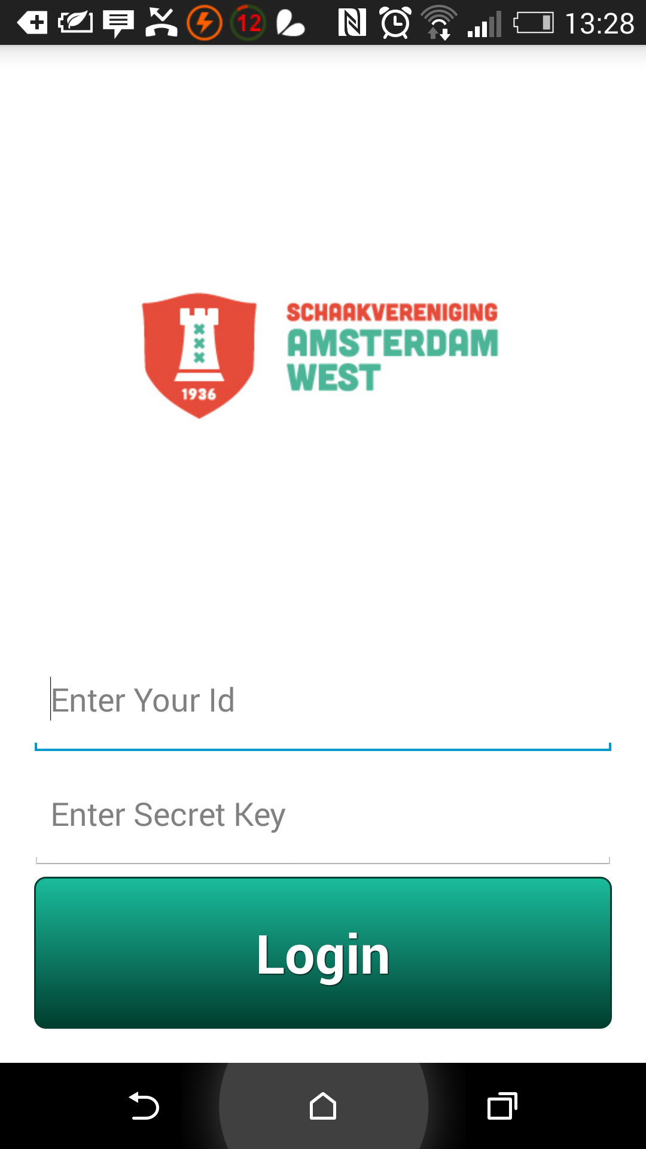

First use:
An ID and secret key provided by the administrator are required.

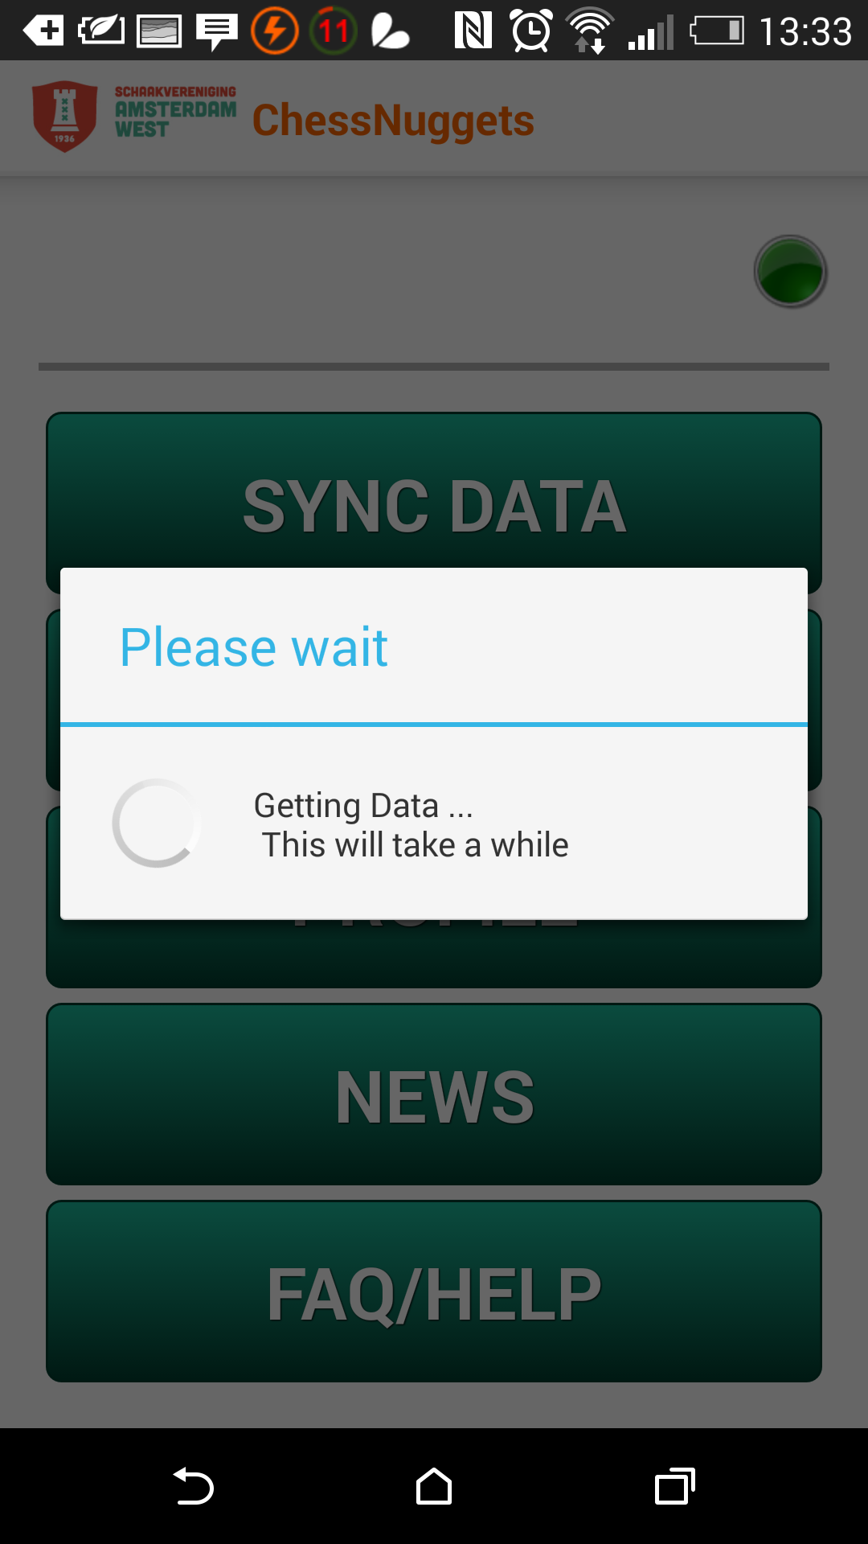

After this the app needs to be synced for the first time, this first process is important.
Press the Sync Button to do this.
Depending on the Internet connection this process can take one to five minutes.

After this the Phone will always boot into the menu screen.
It is advised to use the sync button often. After the first syncing process syncing generally takes at the most 30 seconds.
The green/red light in the top right:
This indicates internet availeability green=internet, red= no internet availeable.

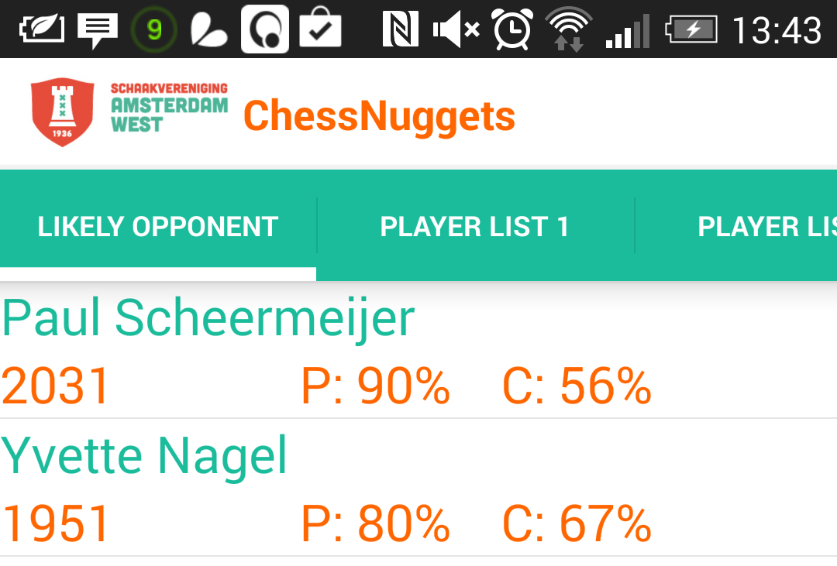
TOURNAMENT:
Default: This will give an Overview over the next three most likely opponents.
P: gives the chance of facing this player next.
C: gives the chance of winningagainst this player calculated via ELO formula.

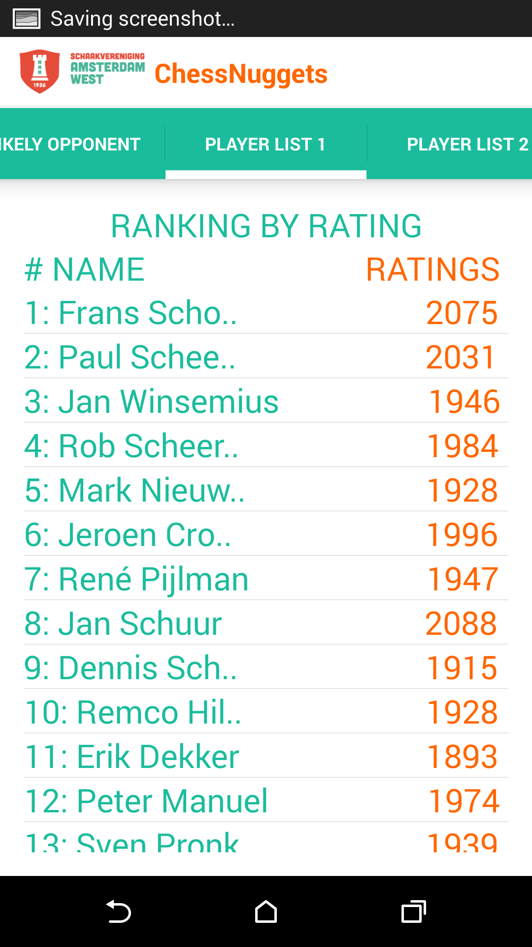

Player List 1 (Scroll Left or click on “PLAYER LIST 1” on top of the page)
Displays all players in the internal competition sorted by rating

Player List 2(Scroll Left or click on “PLAYER LIST 2” on top of the page)
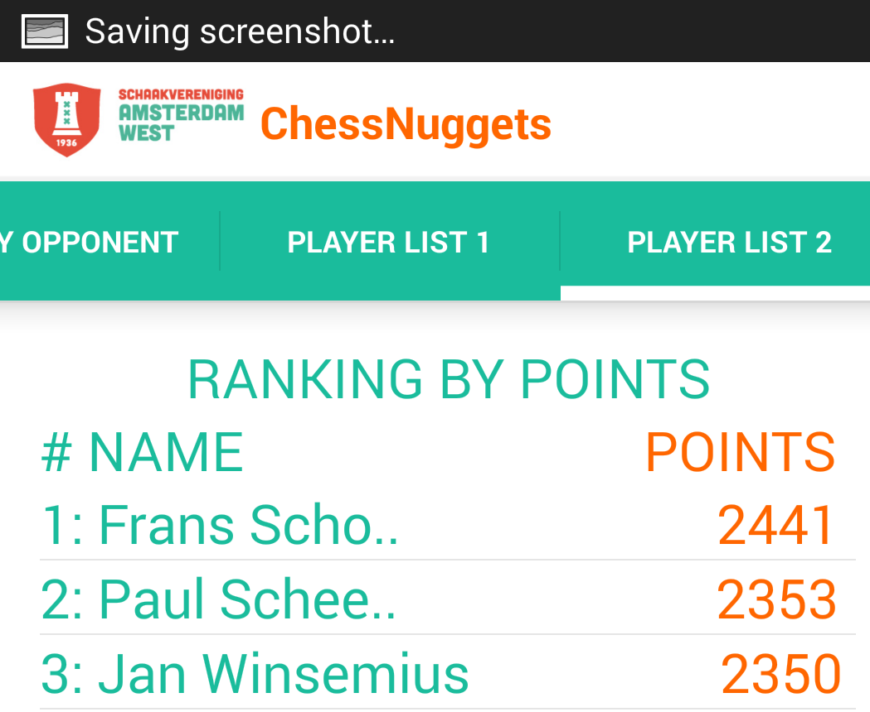
Displays all players in the internal competition sorted by points

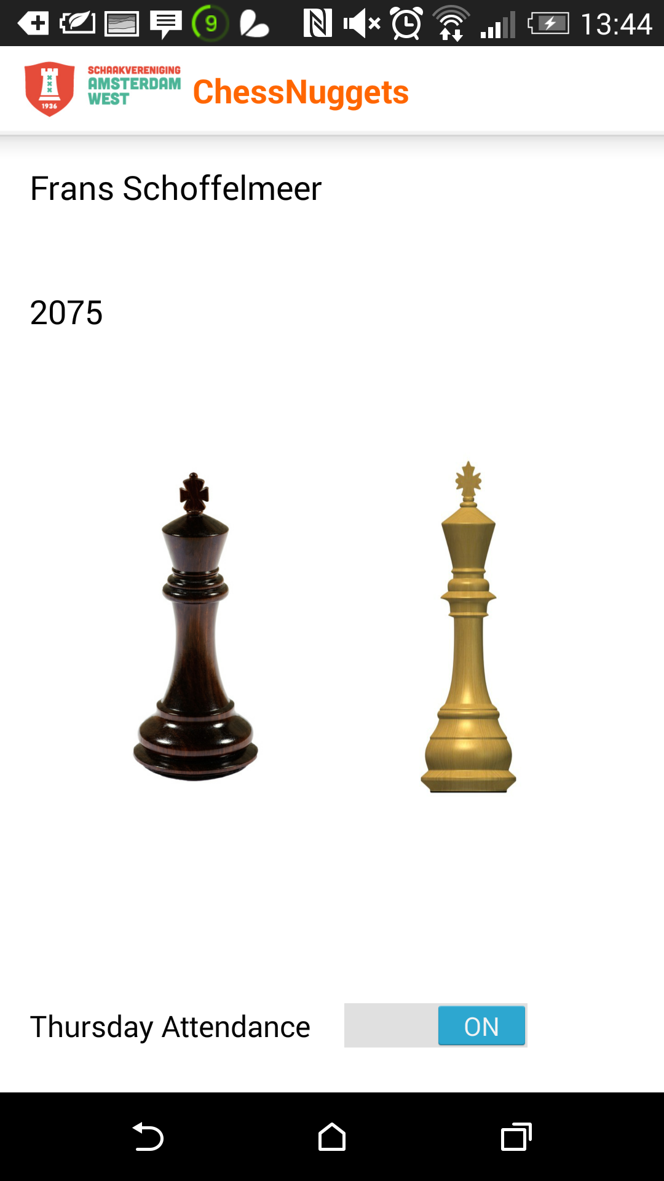
Clicking on any players name in any of the views advances to the Profile page of this Player.
In this view a graph is visible displaying this players record sorted by color.
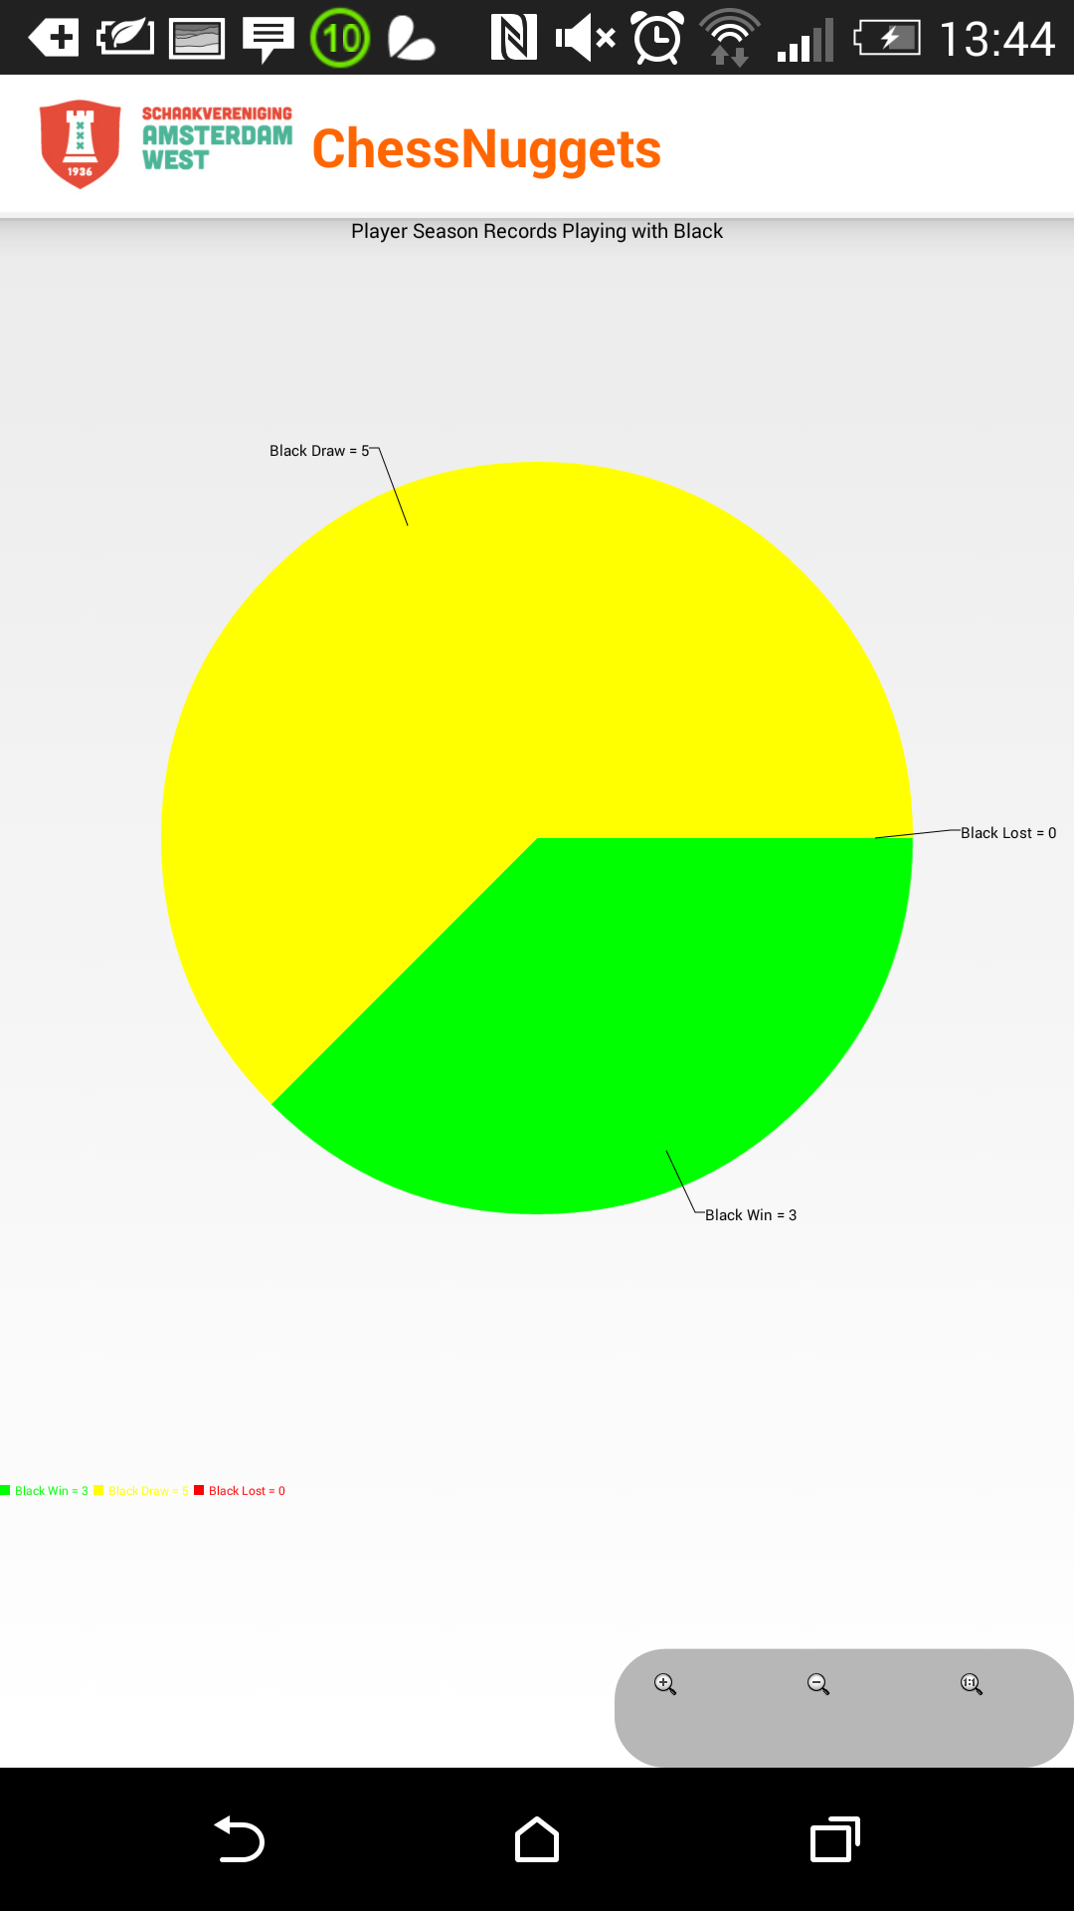

PROFILE:
This is the same screen as the default profile page, with one important difference.
As this is The Users own profile it is possible to sign up here for next weeks attendance.

NEWS:
Not yet implement due to server side problems.

FAQ/HELP:
Will show this text again.

Admin only:
To be an admin the person will have to be unlocked in the web application.
After this simply restart the application.
Once unlocked in the main screen a small button becomes available that opens a dropdown menu.
Clicking the dropdown menus only menu point allows to access the admin list.
This list allows to edit any players attendance for the next week.

4. Maintenance
The app is not being further developed by this group, however, if there are any questions or problems with the current version of the application; please feel free to contact us with the email address:
506423@student.inholland.nl

